Creating tables

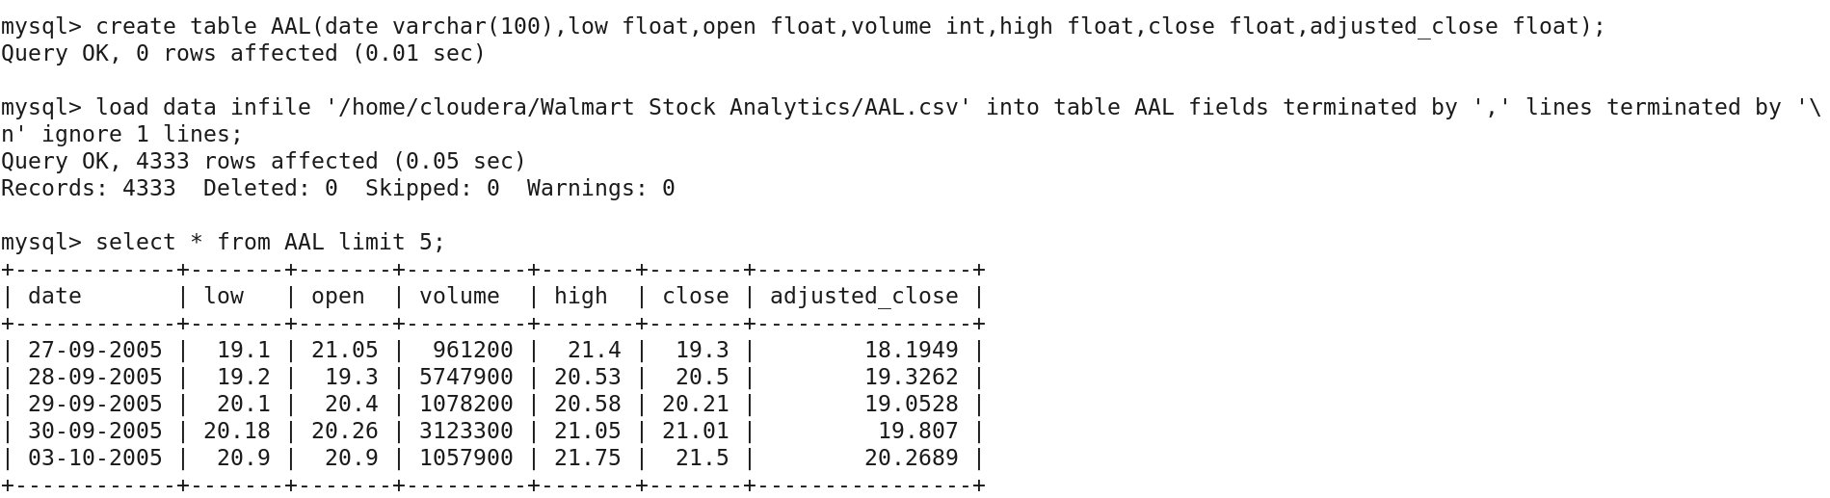

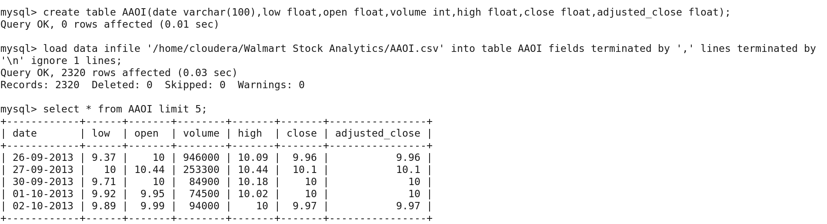

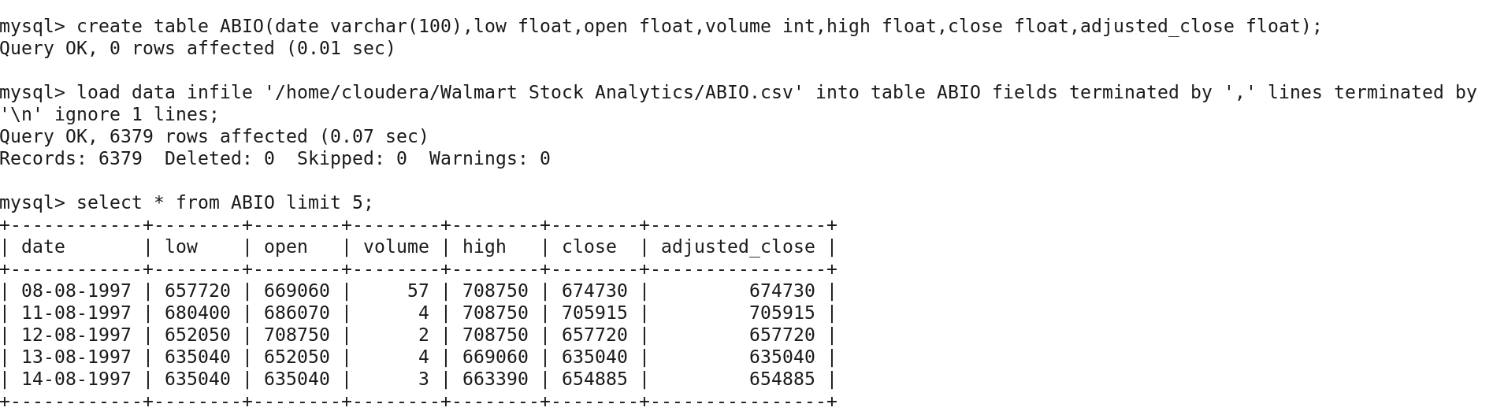

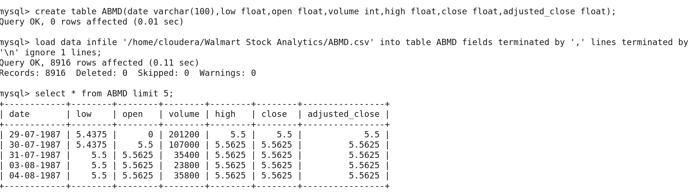

Tables in the Data Base

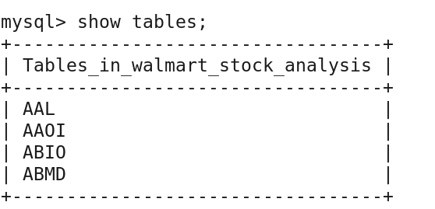

IMPORTING DATA FROM RDBMS TO HDFS USING SQOOP



HDFS Directory :

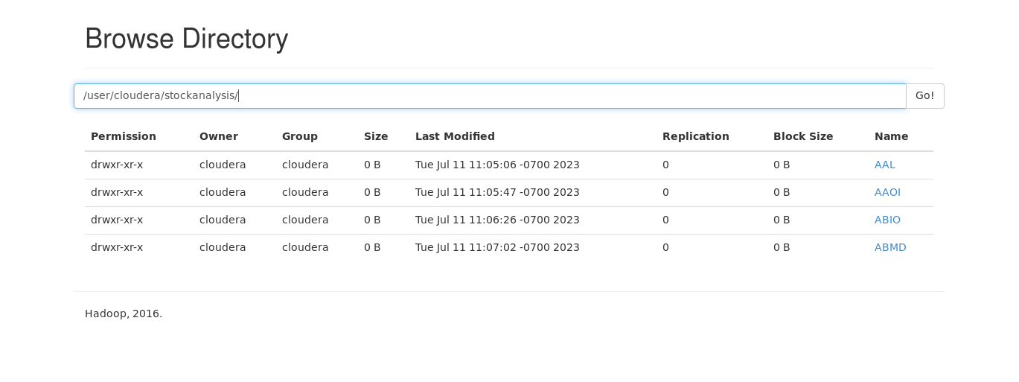

HDFS to HIVE WAREHOUSE :

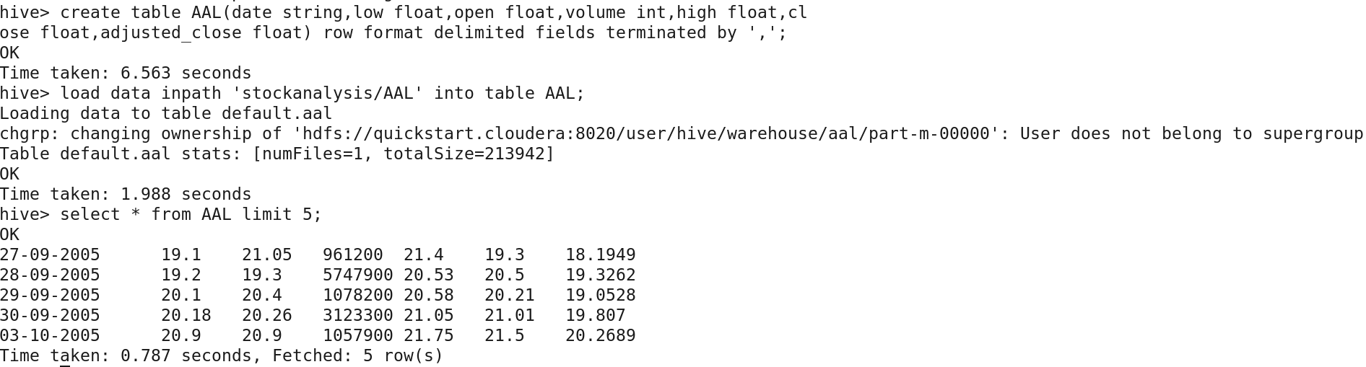

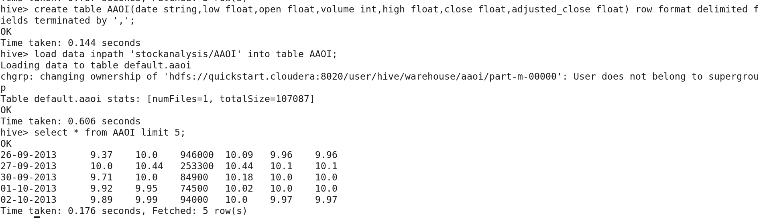

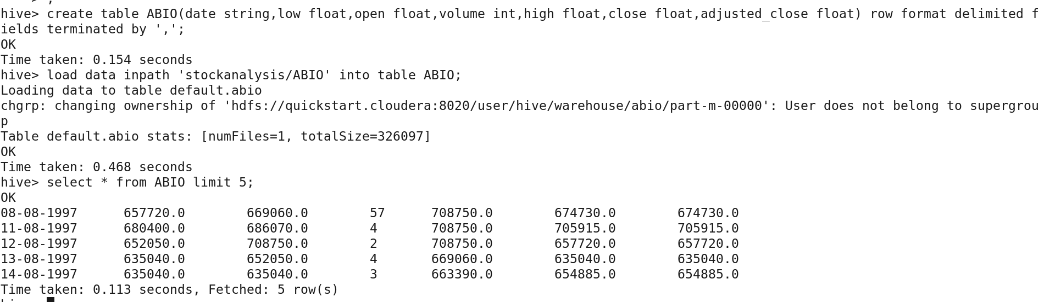

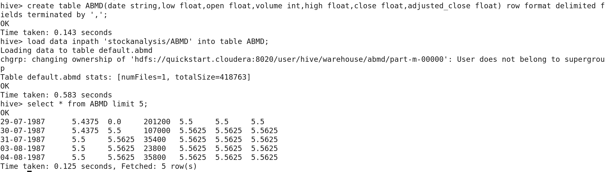

Scenario Solutions :

**PS 1 : Write a Hive query to identify the top three dates that experienced the largest percentage change in stock price (from open to close) for every stock.**



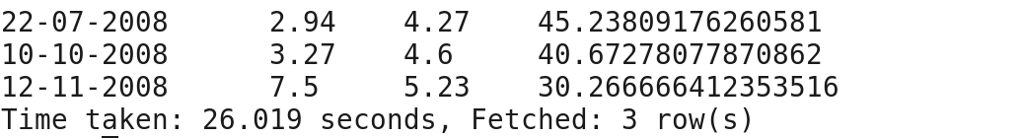



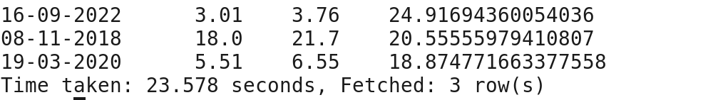



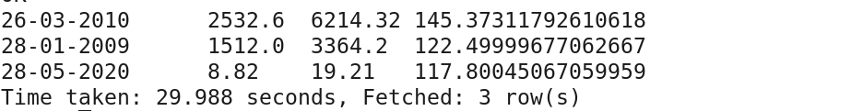



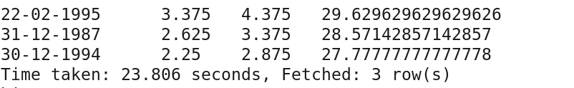

**PS2 :**

**write a Hive query to identify the dates where Low is less than average month low for every stock.**

**AAL**



**SAMPLE OUTPUT :**

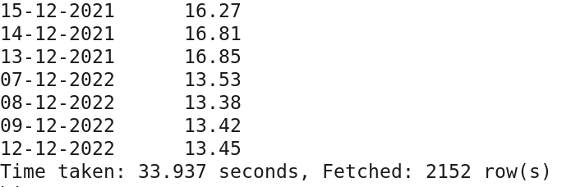

**AAOI**



**SAMPLE OUTPUT :**

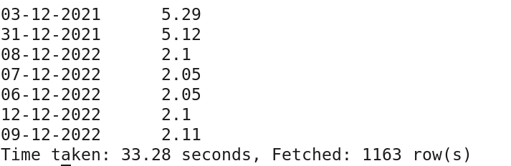

**ABIO**



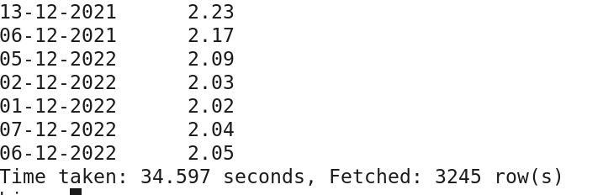

**ABMD**



**SAMPLE OUTPUT :**

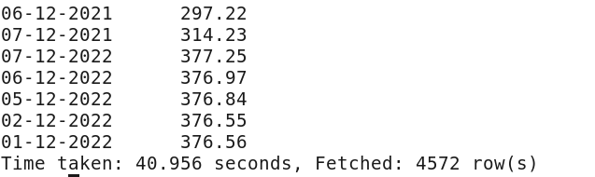

**PS 3 : Write a Hive query to find the date with the longest consecutive streak of increasing closing prices for every stock.**

**AAL**

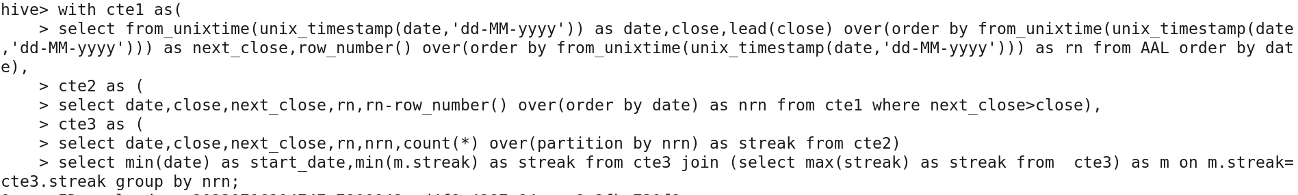



**AAOI**

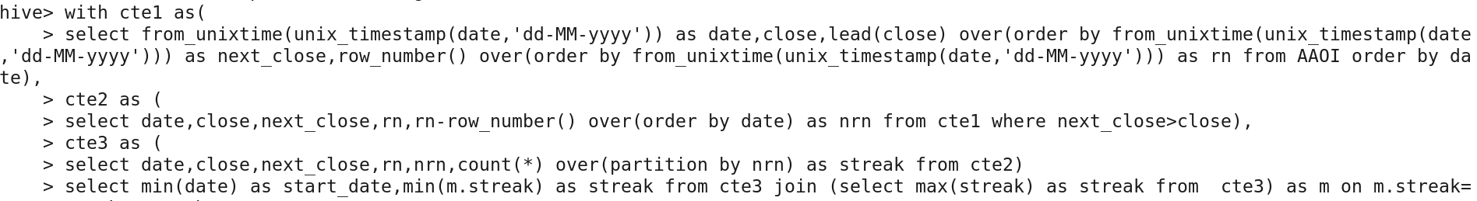

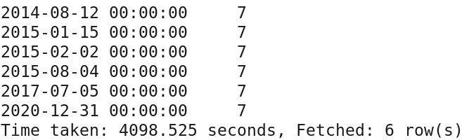

**ABIO**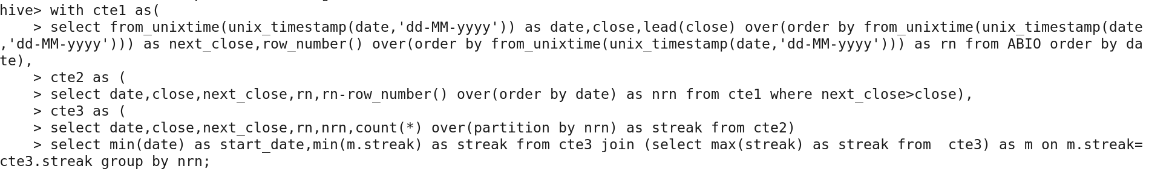

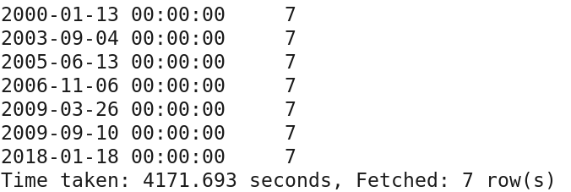

**ABMD**

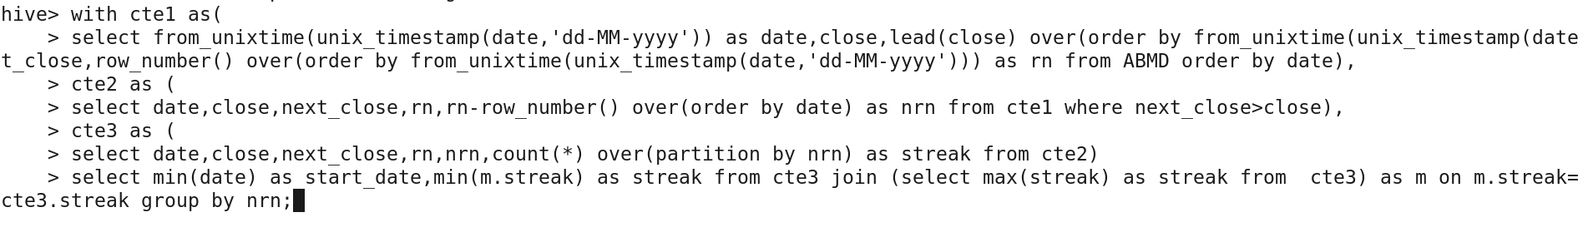



**PS 4 : write a Hive query to find the dates where AAL open price is higher than AAOI open price OR AAL volume greater than AMBD (write your query in an optimised way).**

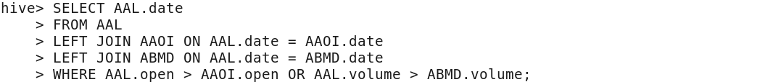

**SAMPLE OUTPUT :**

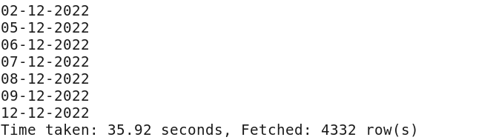

**PS 5: write a Hive query to calculate VH ratio(volume to hive ratio).**



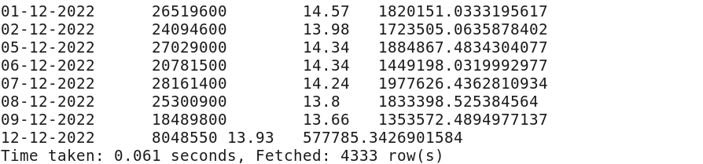



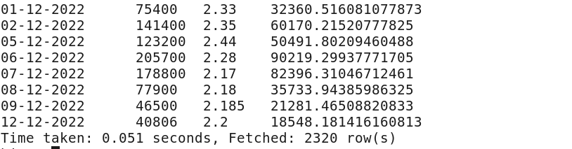



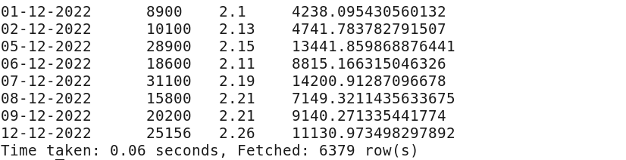



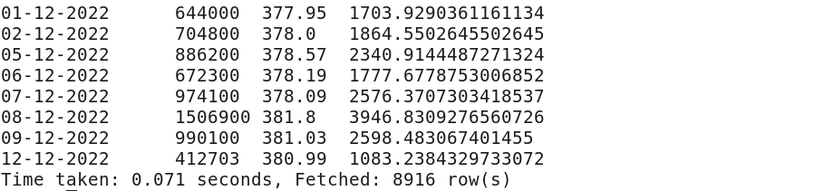

**PS 6 : 6. Write a Hive query to find the dates where previous day close and current day open difference is greater than 0 for each stock.**



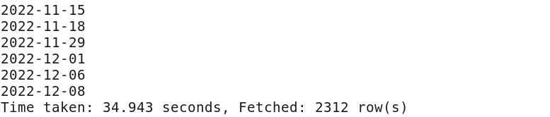



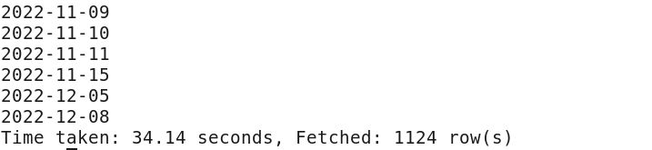



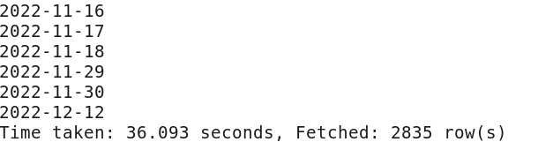



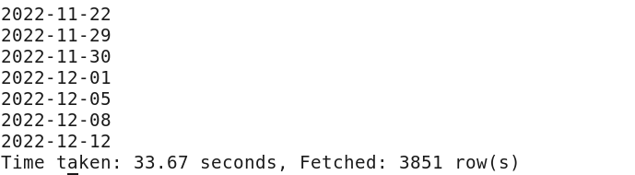

**PS 7 :** **Find median of volume for ABIO.**





**CREATING BUCKING TABLES AND INSERTING DATA INTO IT**

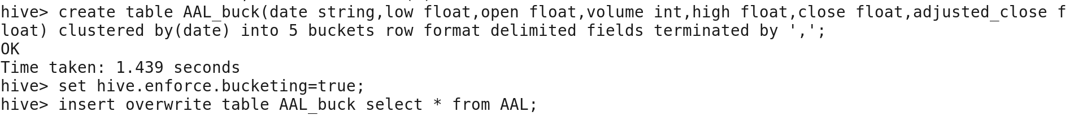

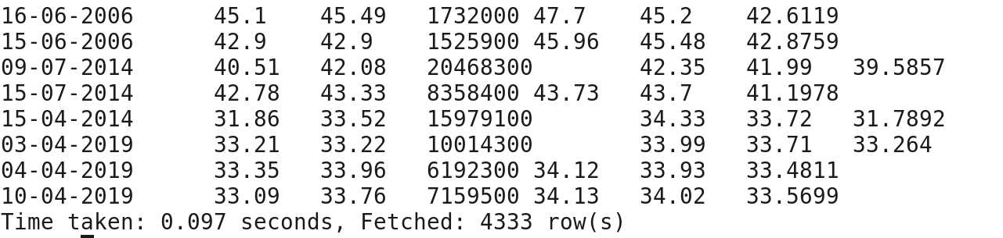



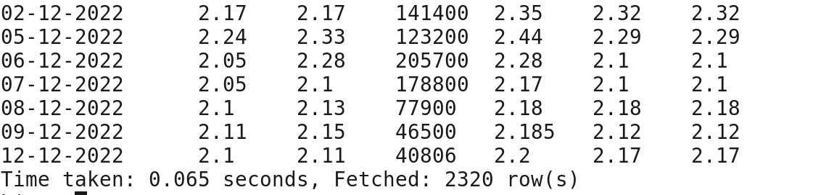



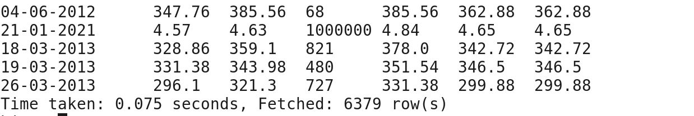



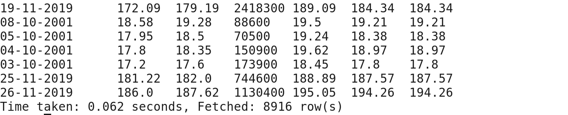

**ANALYZING DATA ON BUCKETED TABLES**

**PS 1 : Write a Hive query to identify the top three dates that experienced the largest percentage change in stock price (from open to close) for every stock.**



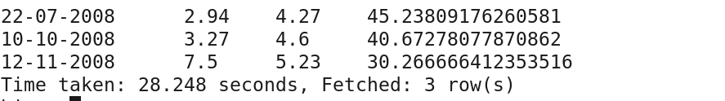



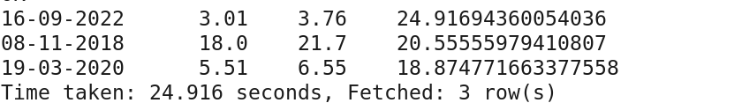



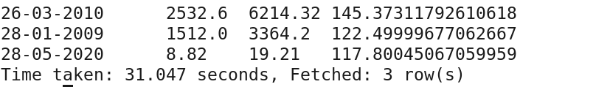



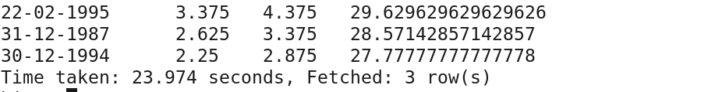

**PS2 : write a Hive query to identify the dates where Low is less than average month low for every stock.**

**AAL**



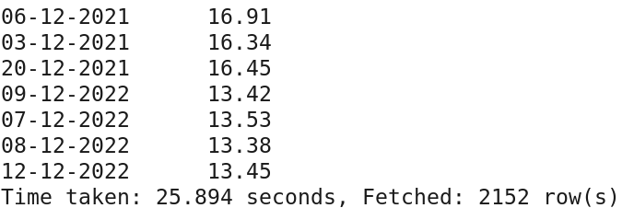

**AAOI**



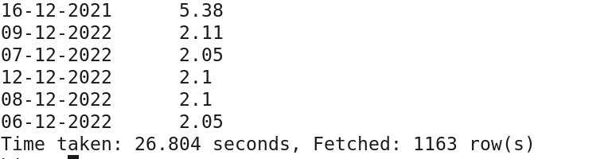

**ABIO**



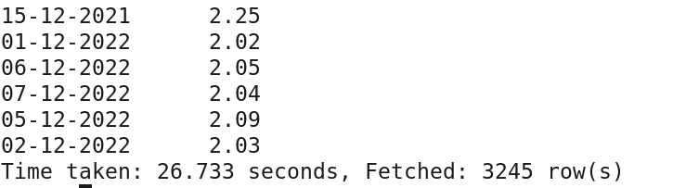

**ABMD**



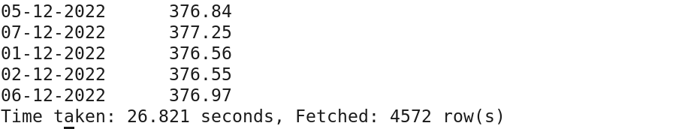

**PS 3 : Write a Hive query to find the date with the longest consecutive streak of increasing closing prices for every stock.**

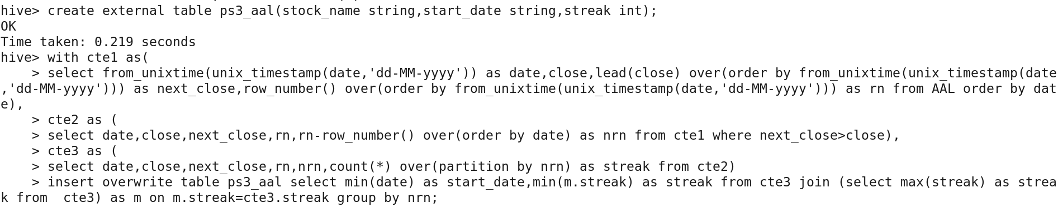

**PS 4 : write a Hive query to find the dates where AAL open price is higher than AAOI open price OR AAL volume greater than AMBD (write your query in an optimised way).**

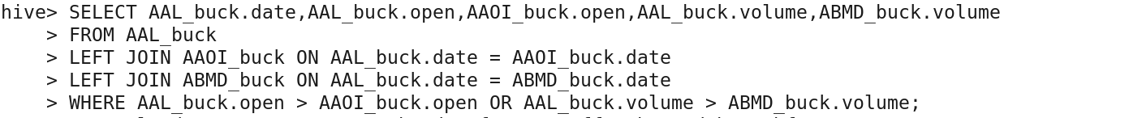

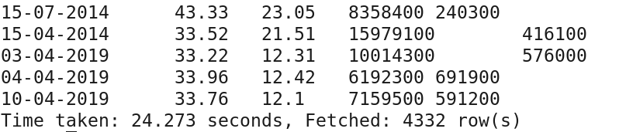

**PS 5: write a Hive query to calculate VH ratio(volume to hive ratio).**

**AAL**



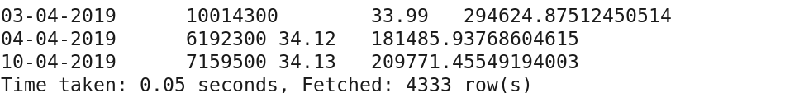

**PS 6 : 6. Write a Hive query to find the dates where previous day close and current day open difference is greater than 0 for each stock.**



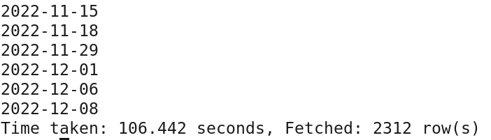



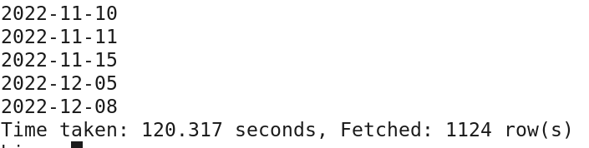



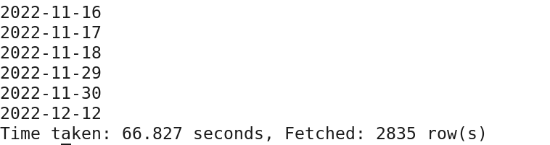



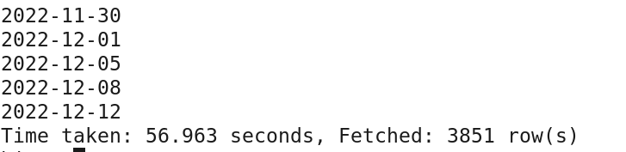

**PS 7 :** **Find median of volume for ABIO.**



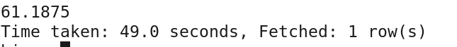

**CREATING EXTERNAL TABLES AND INSERTING OUTPUT DATA :**

**PS 1 :**



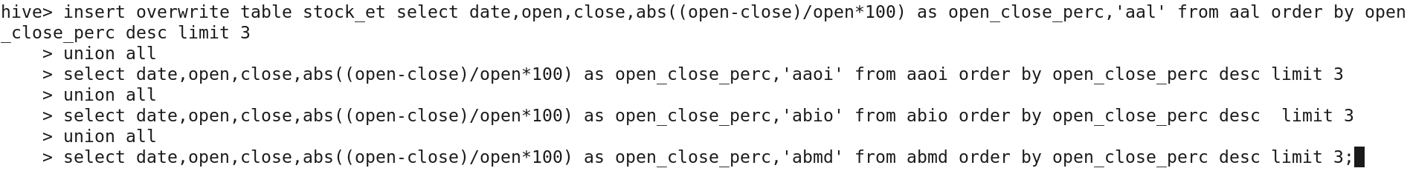

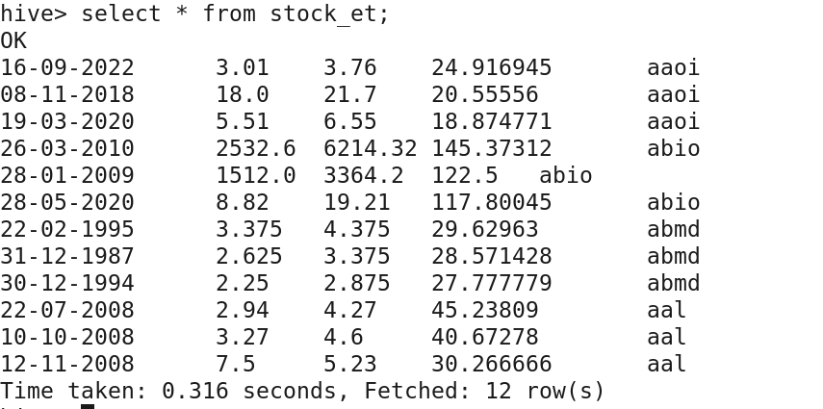

**PS 2:**

**AAL**





**AAOI**

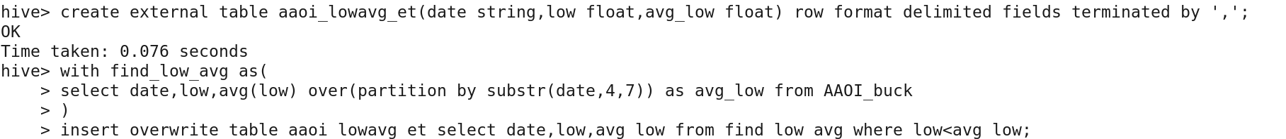

**ABIO**

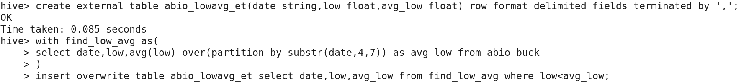

**ABMD**

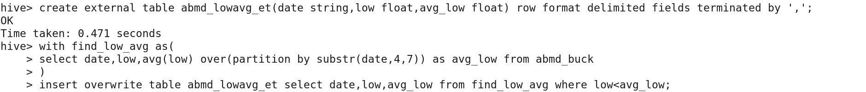

**PS 3:**

**AAL**



**AAOI**

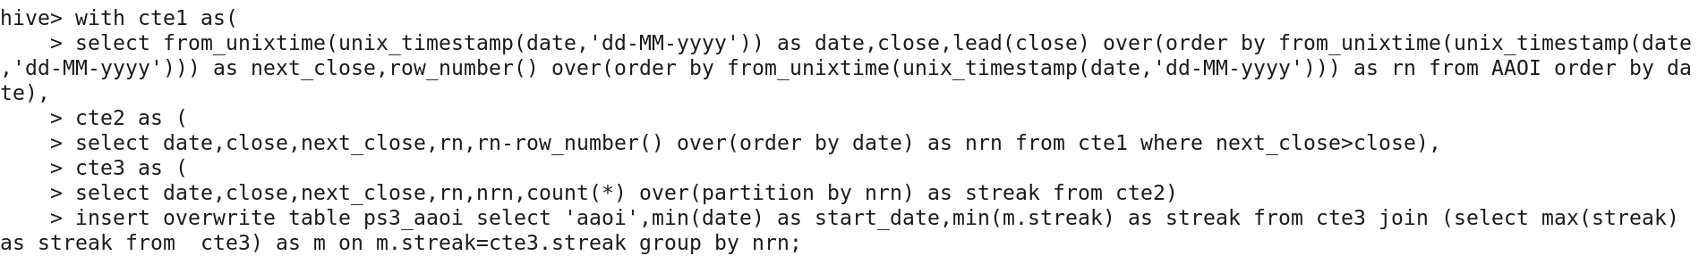

**ABOI**

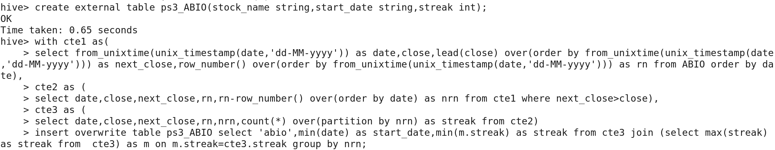

**ABMD**

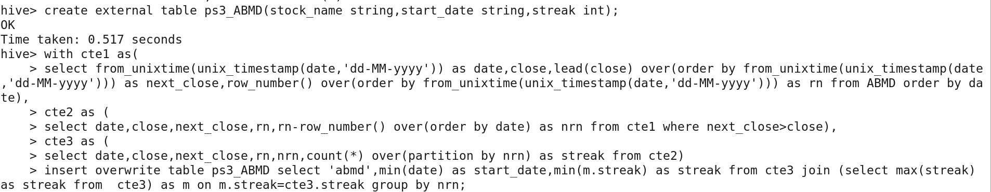

**PS 4:**

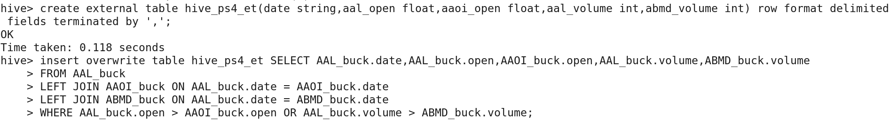

**PS 5:**

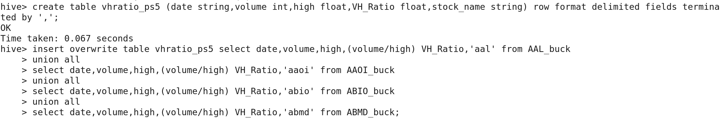

**PS 6:**

**AAL**



**AAOI**



**ABIO**



**ABMD  
**

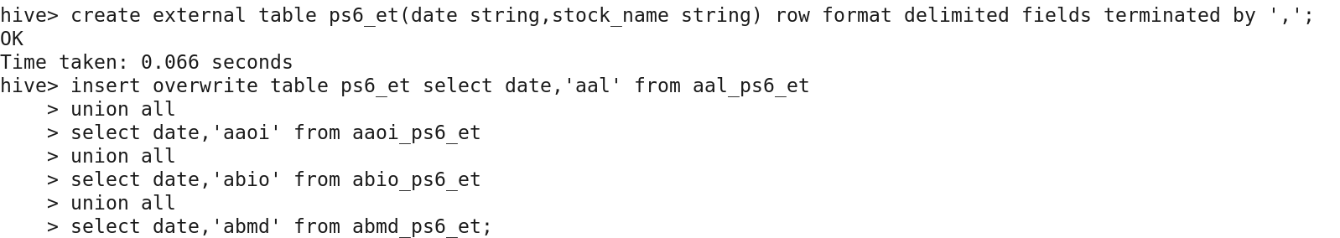

**CREATING TABLES IN MYSQL DATABASE FOR EXTERNAL TABLES**

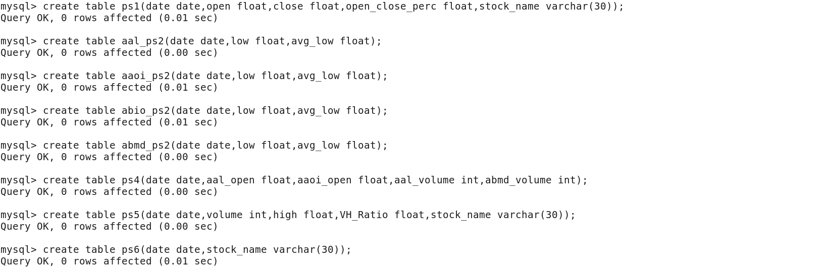

**SQOOP EXPORT FROM EXTERNAL TABLES TO MYSQL**



sqoop export --connect jdbc:mysql://localhost:3306/walmart_stock_analysis --username root --password cloudera --table aal_ps2 --export-dir /user/hive/warehouse/aal_lowavg_et/* -m 1

sqoop export --connect jdbc:mysql://localhost:3306/walmart_stock_analysis --username root --password cloudera --table aaoi_ps2 --export-dir /user/hive/warehouse/aaoi_lowavg_et/* -m 1

sqoop export --connect jdbc:mysql://localhost:3306/walmart_stock_analysis --username root --password cloudera --table abio_ps2 --export-dir /user/hive/warehouse/abio_lowavg_et/* -m 1

sqoop export --connect jdbc:mysql://localhost:3306/walmart_stock_analysis --username root --password cloudera --table abmd_ps2 --export-dir /user/hive/warehouse/abmd_lowavg_et/* -m 1



sqoop export --connect jdbc:mysql://localhost:3306/walmart_stock_analysis --username root --password cloudera --table ps4 --export-dir /user/hive/warehouse/hive_ps4_et/* -m 1 --input-null-non-string '\\N' --input-null-string '\\N'

sqoop export --connect jdbc:mysql://localhost:3306/walmart_stock_analysis --username root --password cloudera --table ps5 --export-dir /user/hive/warehouse/vhratio_ps5 -m 1

sqoop export --connect jdbc:mysql://localhost:3306/walmart_stock_analysis --username root --password cloudera --table ps6 --export-dir /user/hive/warehouse/ps6_et/* -m 1